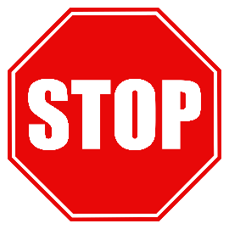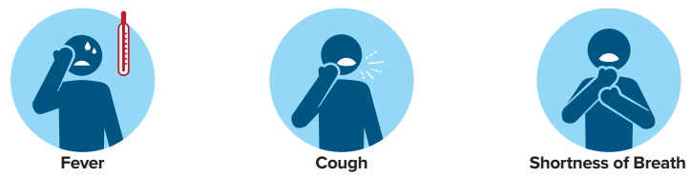 



**School Playground Closed**

**To help slow the spread of**

**COVID-19, under order of**

**North Central Washington regional Health Districts.**

